**Data Analyst Project using python on Foreign Direct Investment Analytics in India**

**Problem Statement:**

Investment is a game of understanding historic data of investment objects under different events but it is still a game of chances to minimize the risk we apply analytics to find the equilibrium investment.

To understand the Foreign direct investment in India for the last 17 years from 2000-01 to 2016-17. This dataset contains sector and financial year-wise data of FDI in India Sector-wise investment analysis Year-wise investment analysis.

**Now let’s start this task by importing the necessary Python libraries and the dataset:**

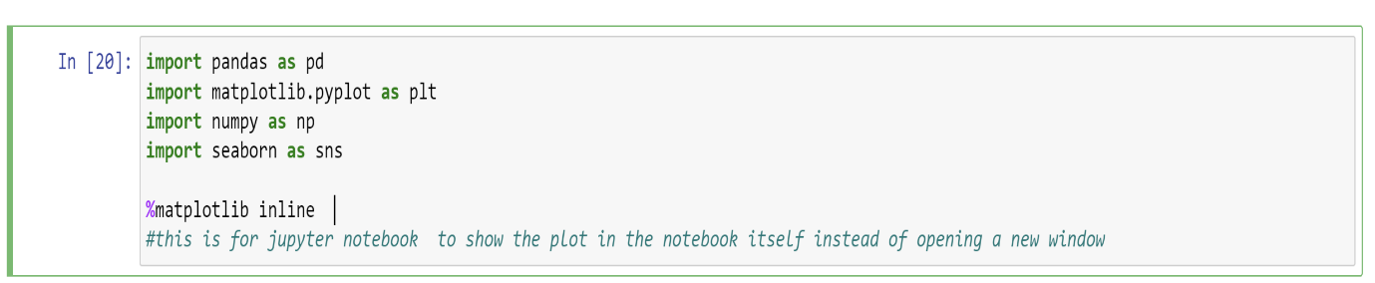

**Reading and loading the dataset:**

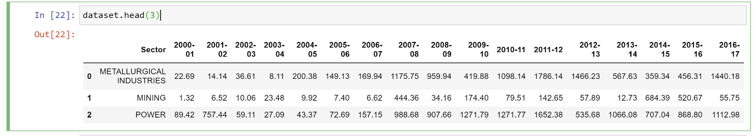**View of the data:**

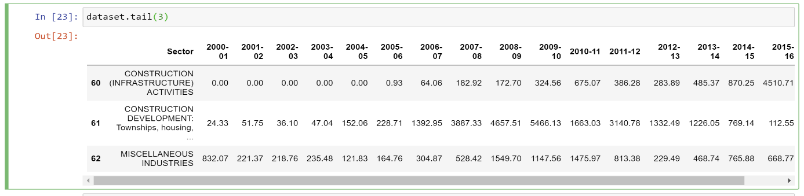

**Checking the shape of the data:**



**Columns Details:**

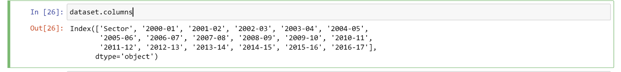

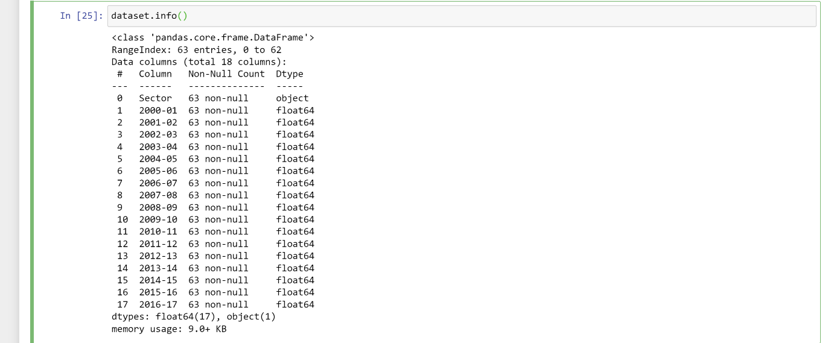**Information about the data:**

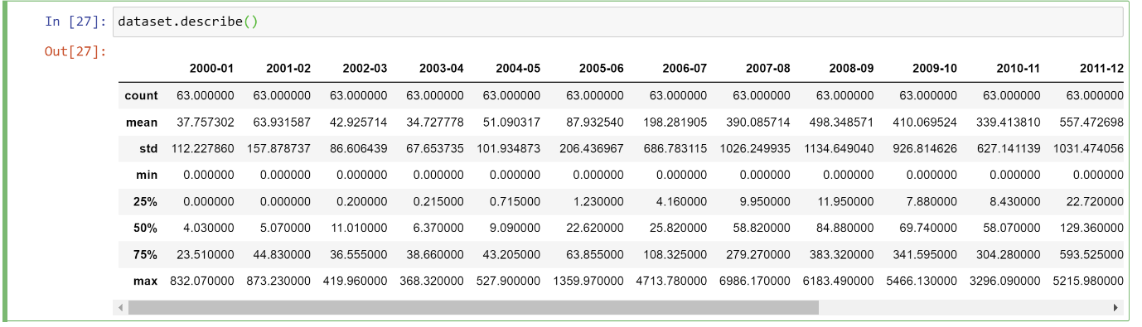

**Checking whether any columns contain null values:**

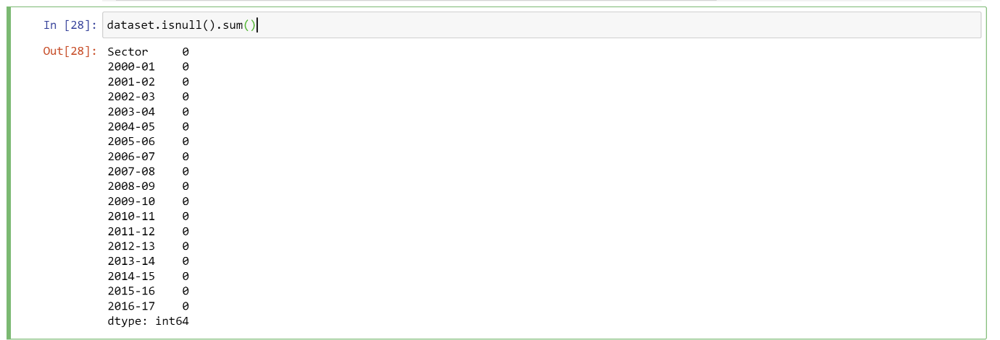

**NOTE:** There are no missing values in our dataset.

**Visualization:**

**Exploratory Data Analysis (EDA)**

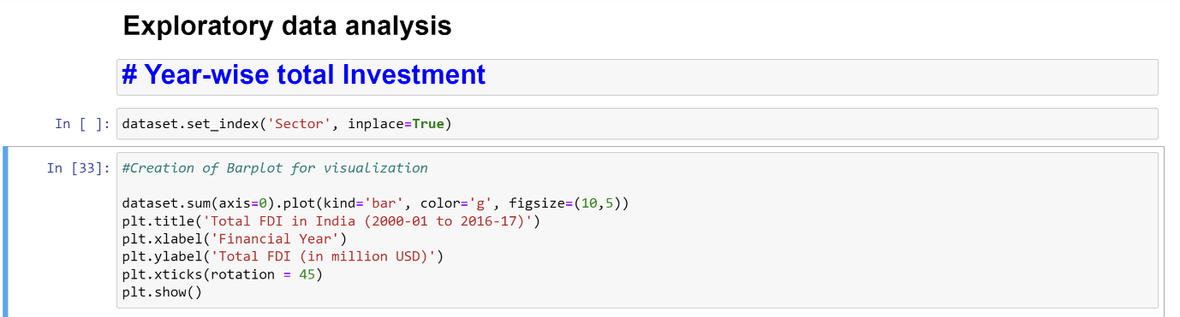**Year-wise total Investment**

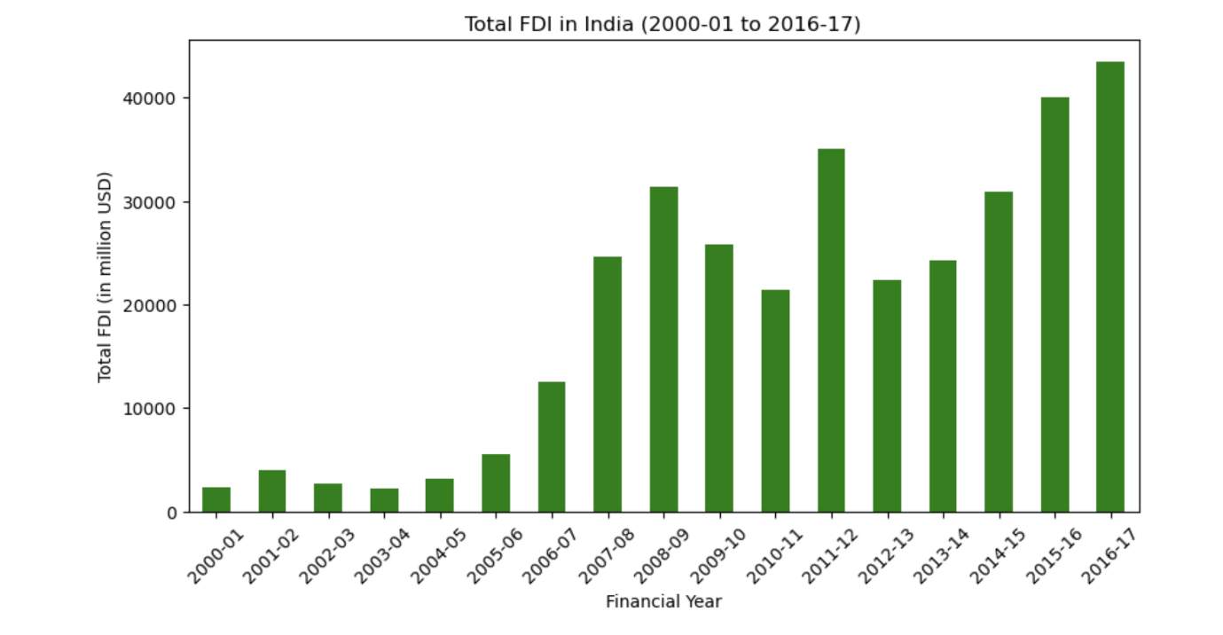

**So, using bar plot, we can say that the highest total investment was done in the year of 2016-17. And in the year of 2000-01,2003-04 was lowest investment.**

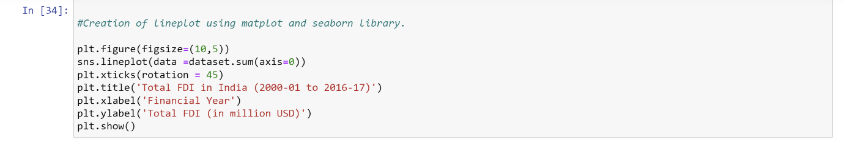

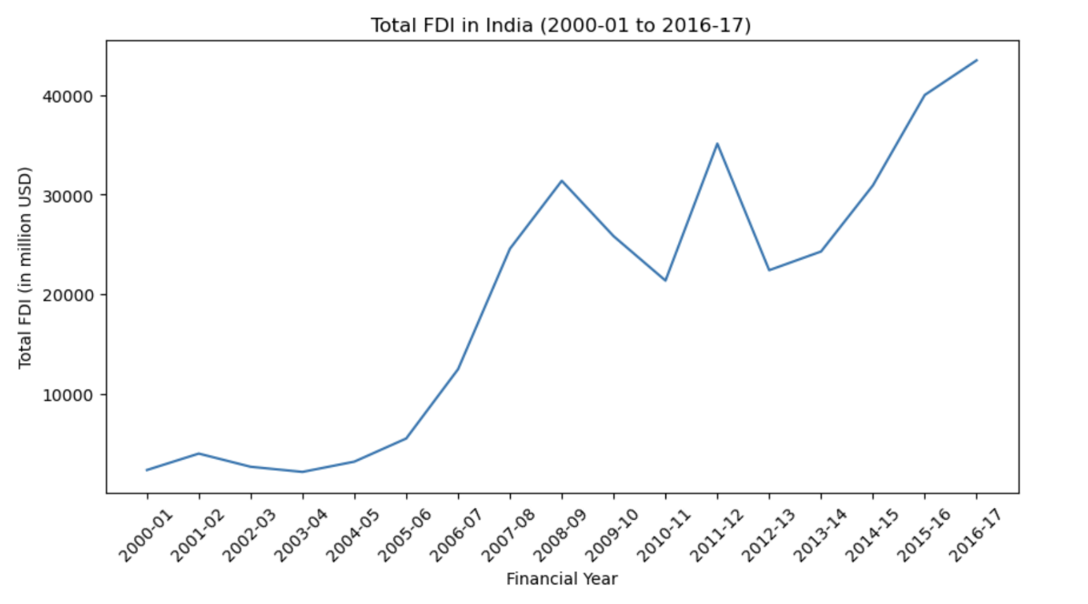

**So, we can see in this plot that total investment is continuously increasing in every year.**

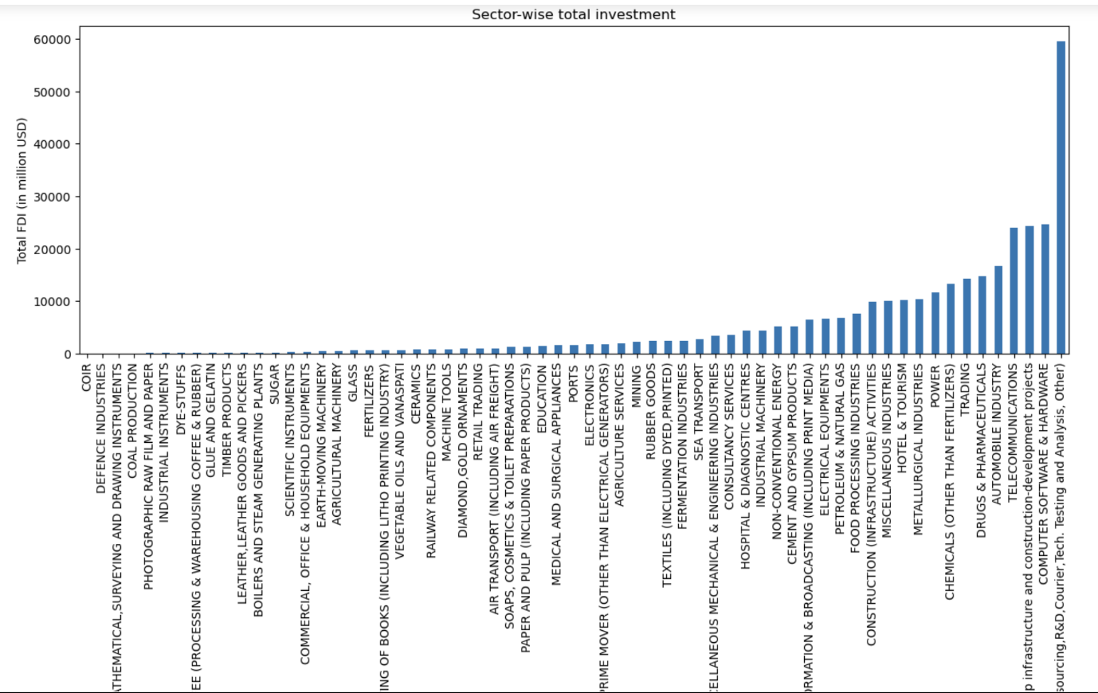**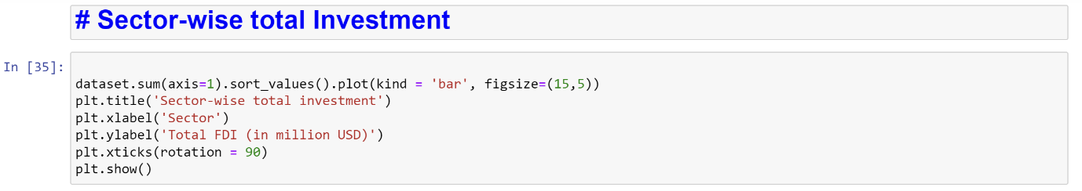Sector-wise total Investment**

**Here we can see that the total FDI of the sectors. Services sector is the highest sector, who was invest highest total of FDI in India. There is very low investment towards sectors like Coir, Defence Industries, Mathematical, surveying and drawing Instruments, Coal Production. There are around 10 to 15 sectors, investment is very less and some of this like zero.**

**NAME: ABHISHEK SAINI**

**EMAIL: sainiabhi983@gmail.com**